Monday Wednesday Friday | 1.  No School- Spring Break | 2. | 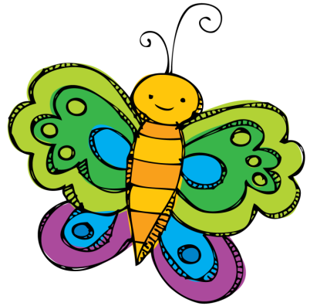  3. | 4. | 5.
Bugs and Insects  Letter of the Week: W | 8.  School Resumes  Snack: Oranges | 9. | 10.  Snack: cheese sticks | 11. | 12.  Snack: Goldfish
Easter  Letter of the Week: X | 15.  Snack: Turkey and Cheese | 16. | 17.  Crazy Bounce Field Trip  9:30-11:30 | 18. | 19.  Snack: Pudding
Under the Sea  Letter of the Week: Y | 22.  Snack: Goldfish | 23. | 24.  Snack: Pretzels | 25. | 26.  Snack: Rice Crispy Treats
Zoo Animals  Letter of the Week: Z: | 29.  Snack: Cheeze-its | 30. | 1.  Snack: Bananas | 2. | 3.  VIP Day -10:00am  Snack: Animal Crackers

Monday Wednesday Friday  Zoo Animals  Letter of the Week: Z |  |  | 1.  Snack: Bananas | 2. | 3.  VIP Day  10:00am  Snack: Animal Crackers
Down on the Farm  Review Letters | 6.  Snack: Go-Gurt | 7. | 8.  Snack: Rice Crispy Treats | 9 | 10.  Snack: Granola Bars
Goodbye Preschool  Review Letters | 13.  Snack: Applesauce | 14. | 15.  Last Day for 3 Year Olds  Snack: Graham Crackers | 16 | 17.  Snack: Cupboard clean out
Goodbye Preschool  Review Letters | 20.  Snack: Cupboard clean out | 21. | 22.  Preschool Graduation  10:00am | 23. | 24.
 | 27. | 28. | 29. | 30. | 31.

